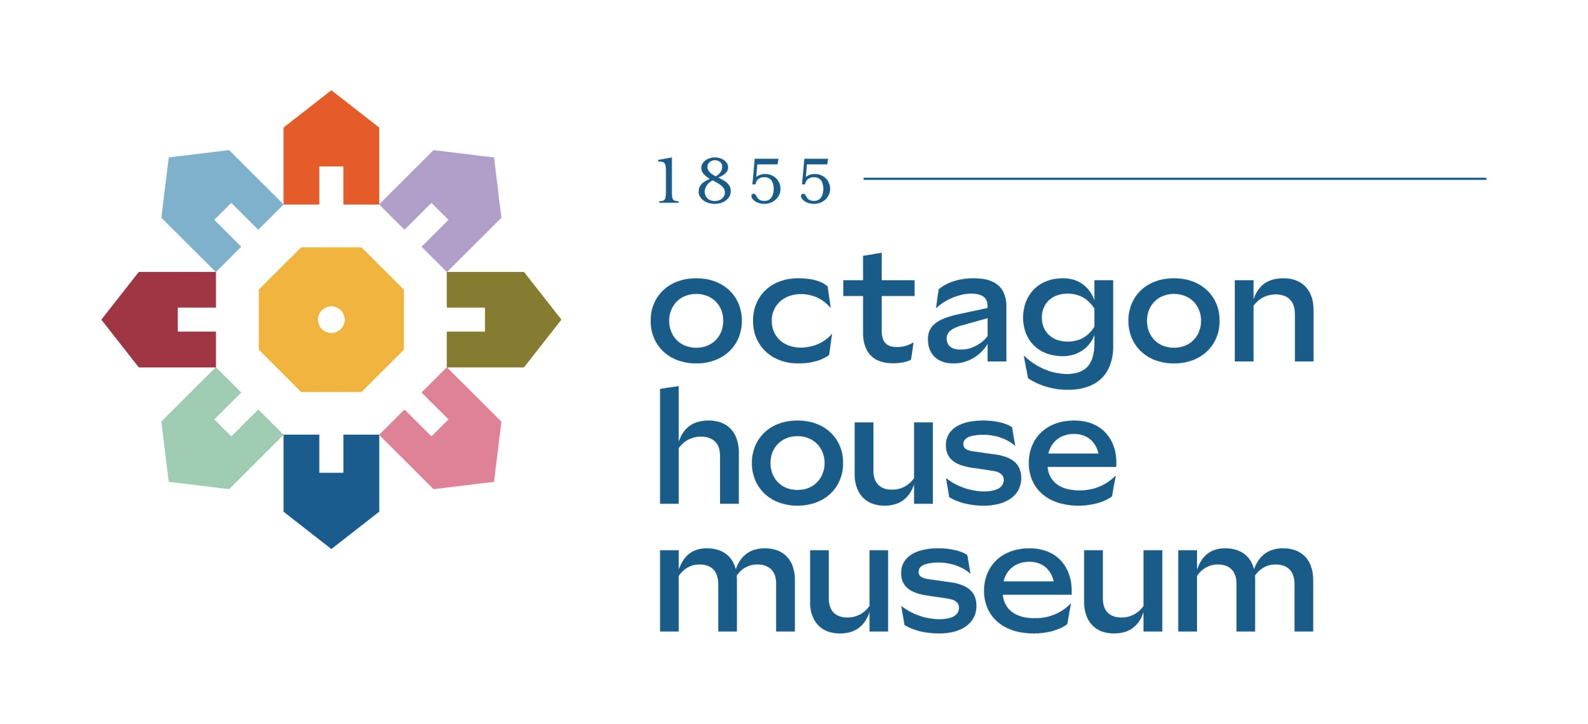
Hudson Area History Connection
Member Application for Annual Membership

Thank you for your interest in contributing to our organization as a Member! Your support is critical to our mission to Bring History to Life in our community. We preserve, interpret, and share local Hudson history through both on- and off-site programs for all ages. Our organization is led by a Board of Directors and employed Executive Director and staff, and is supported and maintained through the generous donation of time and resources from our dedicated volunteer corps.

MEMBER BENEFITS:
- Free admission (per membership level) for at least one tour.
- Discounted tours, event and program tickets, and museum store sales.
- Discounted rental rates for your own gatherings or events.
- Twice-annual Newsletter with first-come opportunities to register for events and special programs.

MEMBERSHIP OPTIONS (Please choose one)

___ Student: $10 Includes 1 admission to tour the Octagon House Museum Complex
___ Individual: $25 Includes 1 admission to tour the Octagon House Museum Complex
___ Family: $40 Includes free admission on Fridays, May through October
___ Supporting: $100 Includes admission for 2 to tour the Octagon House Museum Complex
___Business: $150 Includes ad space on our website and admission for 2 to tour the Octagon House Museum Complex

MEMBER INFORMATION:

Date: __________________________ Level selected/payment amount enclosed: ________

Name: ________________________________________________________________

Phone Number:__________________________________________________________
Address:_______________________________________________________________
Street City State Zip Code

E-mail Address:________________________________________________________
I would like to receive monthly emails with volunteer opportunities and event information (circle)
YES NO

____ Please keep my membership / donation anonymous

ADDITIONAL DONATION OPTIONS:
The Hudson Area History Connection is a (501(c)(3) charitable organization. Tax ID #39-1053844

___ I would like to make an additional tax-deductible gift of: $______________________

___ I would like to make Memorial Donation: in MEMORY or HONOR of:

_______________________ ______________________________________________

___ I would like to make a Legacy or endowment donation. Please have a representative contact me.

RETURN COMPLETED FORM AN PAYMENT TO:
Hudson Area History Connection, 1004 3rd Street, Hudson Wisconsin 54016
OR
Submit form and payment online at: www.hudsonoctagonhouse.org

Payment must be received at the same time as this form for membership to activate, either digitally (via online form and payment) or in-person (mailed with payment or payment received in-person at time of form completion).

_______________________________________________________________
STAFF USE ONLY:

Date Received & Recorded: ____________________ Received by: ____________________

Notes:

